# Warm Up

1. There are 3 machines: **Skywarp, Thundercracker, Starscream**



1. Linux Ubuntu 64-bit
2. Subnet : 255.255.0.0



# Exercise 1 : Web Same-Origin Policy

## Lab Environment Setup

* 1. Setup Apache Server



1. IP Addresses for the DNSs



By using the command “**nmcli dev list iface eth13| grep IP4**”

1. All of the websites (**soplab**, **soplabattacker** and **soplabcollabtive**) accessed from the VM are hosted in **Localhost (127.0.01)**

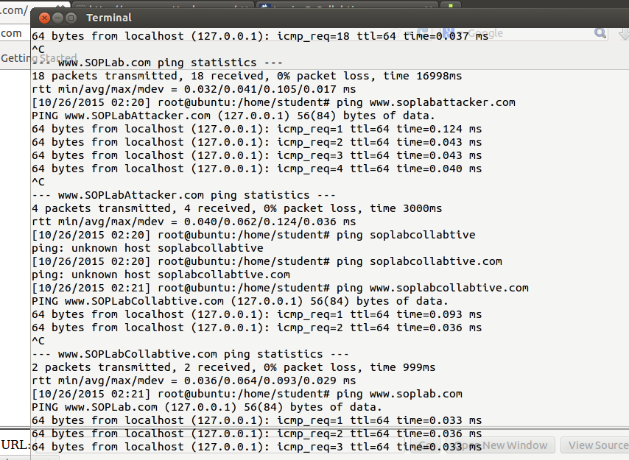

When they were accessed outside the VM, only **soplab**’s address resolves. The other 2 addresses (**soplabattacker** and **soplabcollabtive**) are unreachable

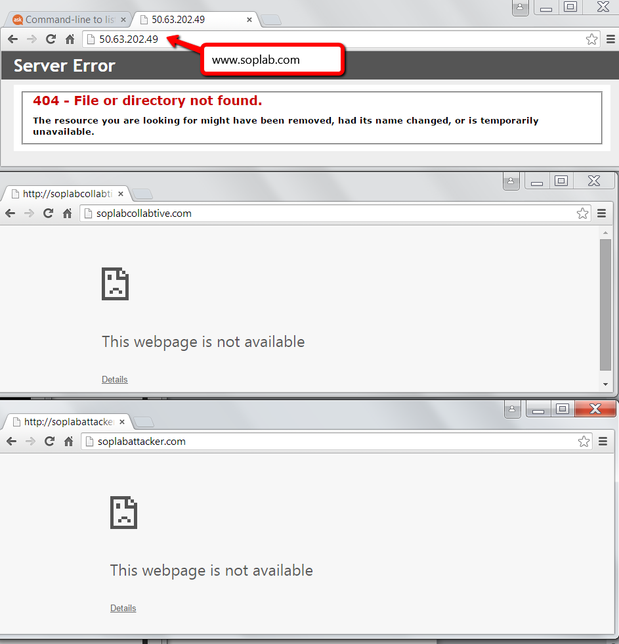

1. 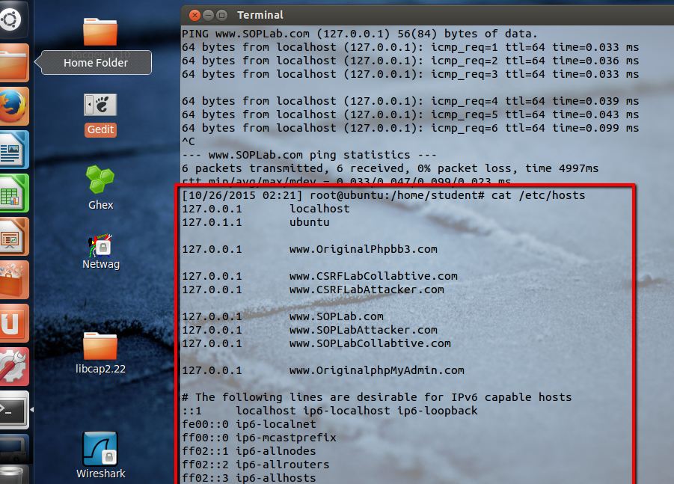 **/etc/hosts**

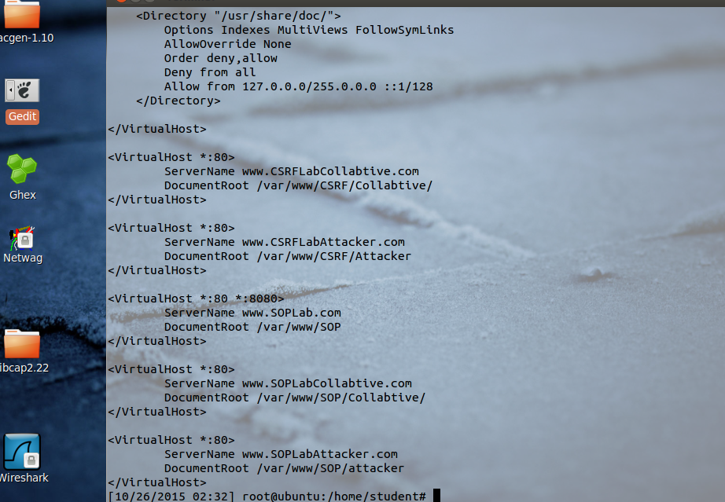In **/etc/hosts**, it defines the IP addresses of the 3 domains that correspond to the Localhost.

In **/etc/apache2/sites-available/default**, it defines the configuration of the web server, which is in Localhost, including the port and the location of the document in the file server, which means, Firefox locates those websites from the VM’s host file, not the DNS server.

* 1. Only 1 user (**admin**) is registered

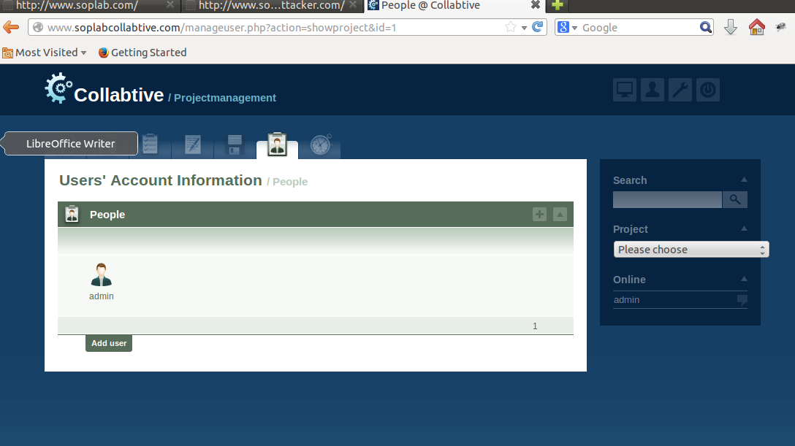

* 1. Disabling cache

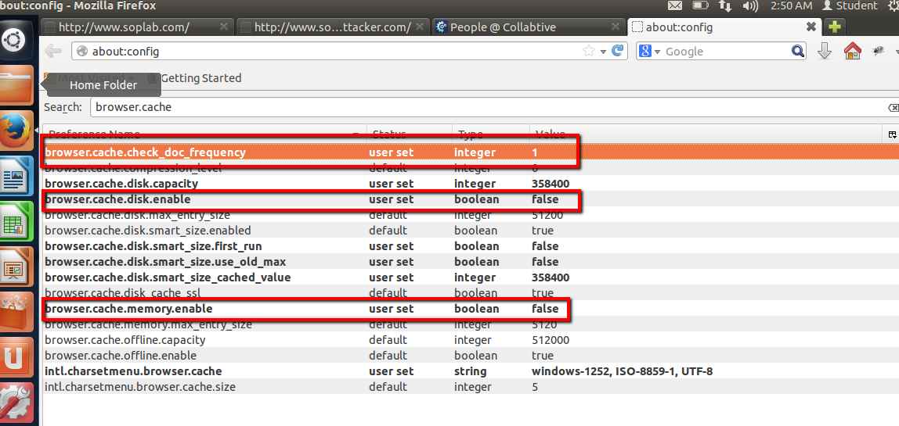

## Understanding DOM and Cookies

1. **Document Object Model (DOM)** is a standard structure from W3C for accessing or modifying contents and formats of a web document / web page by using a tree structure.

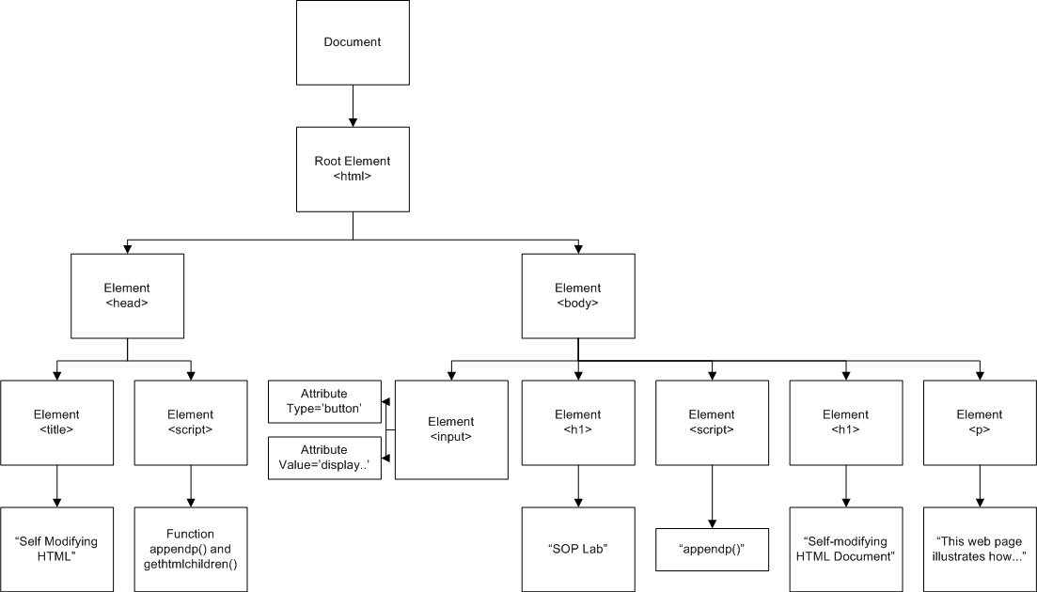

1. ..
2. Cookies are text files that are stored in your local file system, which tracks your data entry, data selection, and user-based settings in a website. They are used to save your preferences, login information, and session management in websites you’ve visited.

In particular, cookies can be created by a defined function provided by the programming language you use (e.g. in Javascript, you can use document.cookie)

A web application may access the cookies stored in your web browser to immediately remember any data entries you’ve done and setup the website using your previously defined settings. A popular example using cookies is shopping cart feature in online shops.

**Expires** is the time limit of when the cookie becomes invalid and is deleted by the browser

**Max-age** is similar with **Expires**. **Max-age** set the expiration time in seconds, while **Expires** sets the expiry date

**Path** is the URL of which the cookie is valid (default is ‘/’)

**Domain** is the domain and the subdomain where the cookie is valid and can be used.

**Secure** means that the cookie transmitted from the server uses encrypted channels

1. **Cookie-based session management scheme** is a management protocol to manage user’s state, preferences, and session in a certain website/web application by using client-side cookies sent by the server.

**Session Cookie** is a client-side cookie to track the pages, data, and item selections which the user has done or visited before in a website.

## SOP for DOM and Cookies

## SOP for XMLHttpRequest

## Exceptions From SOP

## Conclusion

# Exercise 2 -